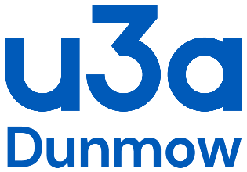
COVID-19 Personal Risk Assessment Consent Sheet
Part 2. Personal Checklist Outcomes:
I have reviewed my own personal health and circumstances in relation to current Government guidance for different risk categories in Covid-19 and what measures are recommended for people in my age group and/or with various medical conditions.

I have considered the health risk category of anyone else I am living with/forming a bubble with.

I have read and understood the risk assessment check list for the
Group completed by the group leader.
I understand that I take part at my own risk. Should I develop Covd-19 symptoms, I will immediately inform the group leader. I understand my contact details may be shared with NHS Test and Trace.

Name | Signed | Dated
Name | Signed | Dated

Issue Date: 3 April 2021

