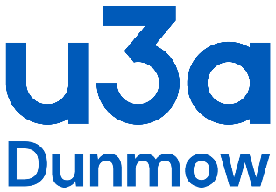
COVID-19 General Activity Risk Assessment Checklist
Name of u3a
Dunmow
Interest Group

Date
Location, including postcode
Is venue Covid-19 secure? Yes / No ( If NO do not proceed)
Nature and Description of Activity

Part 1: Before the activity Group Organiser Check list: |  | Please complete
A)  B)  C)  D)  E)  F) | Consider the current Government and Public Health advice in relation to your location and the feasibility of carrying out this activity safely adhering to present social distancing requirements and permissible indoor and out-door activities.  Consider whether your activity involves the sharing of any equipment or shared spaces and make suitable arrangements to have antiviral cleaning products available.  Where necessary inspect area prior to starting activity to ensure adequate social distancing can be maintained throughout and to remove/isolate any hazards.  Ensure travel arrangements also meet the necessary requirements.  Consider the general hazards related to this type of activity, the impact accommodating Covid-19 requirements may have on the way it is organised.  Record outcome of these considerations in writing prior to the activity and share with participants so they can complete their personal checklist in line with the information in your checklist.

Part 1. Activity Checklist outcomes: |  | Yes (✓)
Any members who have symptoms of Covid-19 virus (raised temperature, dry cough, shortness of breath or loss of taste) should not attend.

It is important to maintain social distancing and good hygiene when visiting these spaces.

No one should share food or drinks.

All members should wash their hands thoroughly for at least 20 seconds using soap and water before and after the group activity.

Please add any other group specific outcomes:

Signed Group Organiser: |  | Dated:

Issue Date: 3 April 2021

